The Twelfth Japanese Speech Contest for University Students

Individual Presentation Category
Application Form and Guidelines

Contents

1. Application Form Guidelines

2. Individual Presentation Category Application Form

3. Tutor Confirmation Form

4. Checklist for Applicants

This application form is only for those applying for the Individual Presentation Category. If you would like to apply for the Speech Category or Group Presentation Category, please download the relevant application form from www.jpf.org.uk/language.

The Twelfth Japanese Speech Contest
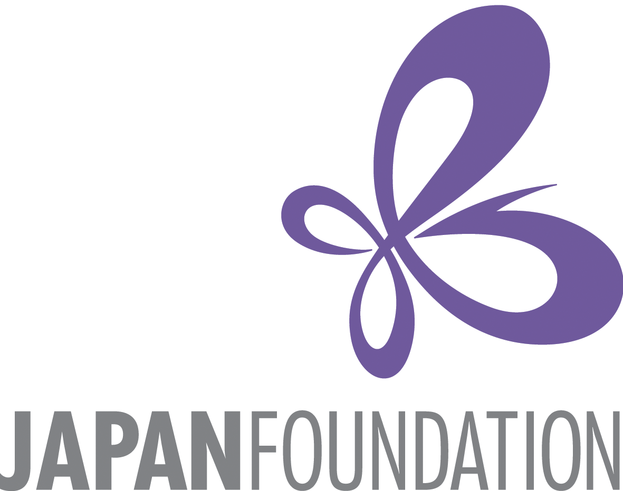

for University Students

1. Individual Presentation Category
Application Form Guidelines
Instructions:

- Please send your completed application form in Microsoft Word format (.doc or .docx) by e-mail to info.language@jpf.org.uk before midnight on Thursday 24th November 2016, with a carbon copy (CC) to your Japanese tutor (please inform your tutor that you will be doing so).
- Your tutor must then complete the Tutor Confirmation Form and return it to info.language@jpf.org.uk in order for your application to be valid. Please inform your tutor in advance that you are planning on entering the contest, and that he/she will be asked to confirm your eligibility. Your application will only be accepted after your tutor has confirmed your eligibility.

Eligibility for the Individual Presentation Category:
The contest is open to undergraduate students who:

- Are studying Japanese as a foreign language as either a degree or non-degree course at a university in the UK or Ireland.
- Who have spent fewer than three consecutive months since the age of six in Japan, OR fewer than a combined total of six months since the age of six in Japan.
- Candidates with Japanese parents are welcome to apply.
- Postgraduate students are not eligible.

Please note that this category is aimed at students with post-beginner/intermediate level Japanese.
If you are still unsure which category you are eligible for, please contact info.language@jpf.org.uk, specifying the name of your degree course, Japanese course and university.

Presentation Details:

- Presentations should be given in Japanese and last 7-10 minutes.
- There will be no questions after the presentation.
- The theme of the presentation should be an introduction to something from the U.K. or another country outside of Japan. It is fine to include Japan for comparative purposes or as a minor part of your presentation; however, the main focus of your presentation should be on something from a country outside of Japan.
- The audience will include native speakers of Japanese and those learning Japanese as a foreign language. We recommend that you choose a theme (e.g. a particular region, event, custom, etc.) that will appeal to this audience.
- Please note that your final presentation must be made in Microsoft PowerPoint format. Other formats will not be accepted.
- When you submit the presentation video, please be aware that this is your final and completed version, which will be presented to the selection panel of judges. The video should contain the presentation of the presenter and the PowerPoint slides on the same screen.
- You may not include any sound, video clips or other moving images in your presentation.
- All images in your PowerPoint presentation must be referenced with their source, if they are not copyright free. The source must be full and correct – search engine URLs are not acceptable. The source can either be listed together with each image, or listed on a final slide at the end. You should also cite any other resources you have used for any other aspects of your presentation (eg. quotations).

Schedule:

Deadline for submitting this application form: Before midnight, Thursday 24th November 2016
Deadline to record and submit a video of your presentation: 25th January 2017. You must submit the following two items. (Detailed instructions on how to submit these will be given after you apply).
- a digital video recording of you giving your presentation.
- the presentation itself, as a Microsoft PowerPoint file.
Notification of result: Early February 2017
Successful applicants will be invited to give their presentations at the speech contest finals.
Speech Contest Finals: Saturday 4th March 2017 at King’s College London.
Speeches and presentations will take place in the afternoon. This will be followed by the award ceremony in the early evening, and a reception in the evening.
This form can be downloaded from www.jpf.org.uk/language or www.batj.org.uk. For all enquiries, please telephone 020 3102 5021or e-mail info.language@jpf.org.uk.
The Twelfth Japanese Speech Contest
for University Students
2. Individual Presentation Category

Application Form
This application form is only for those applying for the Individual Presentation Category. If you would like to apply for the Speech Category or the Group Presentation Category, please download the relevant application form from www.jpf.org.uk/language.

Title (Mr, Ms, etc.):
First name(s): |  |  | Surname:
First name(s) in katakana: |  |  | Surname in katakana:
First language: |  |  | Mobile number (including country code if outside the UK):
E-mail address:
Term-time address: | Address line 1:
Term-time address: | Address line 2:
Term-time address: | Address line 3:
Term-time address: | Address line 4:
Name of University:
Name of Degree Course: |  |  |  |  | Year of degree course:
Name of Japanese course(s) enrolled on: | (e.g. Japanese 2A and 2B, Business Japanese 1, etc.)
Name of main Japanese course tutor:
Course tutor’s email:
Did you study Japanese before entering your current university? | Yes  No | If yes, where?  (Please state institution, location and dates)
 | Exam(s) passed:
Total time spent in Japan since the age of six: | years months
Presentation Theme: | In Japanese:  In English:  Please write the broad theme that you would like to make your presentation on. If you wish to make minor changes to this theme, please contact us before you submit your video and PowerPoint file by 25th January 2017.

Please tick:
I confirm that I have read the eligibility criteria and that I am qualified to enter the contest.
I confirm that my presentation will be my own work
I give my consent for any photographs or videos taken of me during the contest to be used by the Japan Foundation and BATJ for publicity purposes, including making photos/videos available to the public via the internet.

Name of Applicant: Date:

This form can be downloaded from www.jpf.org.uk/language or www.batj.org.uk. For all enquiries, please telephone 020 3102 5021or e-mail info.language@jpf.org.uk.

The Twelfth Japanese Speech Contest
for University Students

3. Tutor Confirmation Form
(To be completed and returned by the course tutor
named in the above application)

How to complete this form:

1. The applicant informs their main course tutor for Japanese that they intend to enter the Twelfth Japanese Speech Contest for University Students, and makes the tutor aware that they must complete this Tutor Confirmation Form to ensure the entry is accepted.

2. Applicants send this form to info.language@jpf.org.uk, and carbon copies (CCs) in the course tutor for Japanese named in the application

3. Course tutor reviews the details of the applicants that have referred them and ticks the confirmation below.

4. Course tutor returns the completed form by email to info.language@jpf.org.uk

Please note that this application will not be complete until we received this completed confirmation form by email directly from the course tutor referred to in the application.

To the Japanese course tutor of the applicant named in this document:
Please complete and return this form as soon as possible to ensure that your student’s application is accepted.

First name:
Surname:
Position:
University:
Name of student(s):
I confirm that I am the main Japanese tutor of the relevant applicant(s) named in this application.
I confirm that to the best of my knowledge, all details supplied by the above applicant(s) are correct.
I confirm that I have read the eligibility criteria, and that the applicant(s) named here meet the eligibility criteria for their chosen category to the best of my knowledge.

Date:

The Twelfth Japanese Speech Contest
for University Students

4. Checklist for Applicants
(for applicants’ own personal use)

Before submitting your application, all applicants should double-check the following:

You have checked your eligibility for the Individual Presentation Category.

All your contact details and university course details are correct.

You have included all details about previous visits to Japan.

All course tutors for all applicants in this category have been informed that you are applying for the contest, and that they are aware that they must submit a confirmation form in order to complete your application.

You have returned the application form by email, and have CCed in the course tutor named in the application form.

You return the application form before midnight to info.language@jpf.org.uk on Thursday 24th November 2016.

You have received a confirmation email from the Japan Foundation (info.language@jpf.org.uk) within 3 working days of sending your application (if you do not receive this email, please call the Japan Foundation on 020 3102 5021 )

We encourage you to apply at least one week before the deadline to ensure that any potential problems with your application can be resolved before the deadline.

Good luck!

