The 18th Japanese Speech Contest for University Students

Group Presentation Category
Application Form and Guidelines

Contents

1. Application Form Guidelines

2. Group Presentation Category Application Form

3. Tutor Confirmation Form
Important Notice

Although we are planning on holding the Finals Day event in-person, if the situation with Covid-19 changes the event may be moved online. Thank you for your understanding.

4. Checklist for Applicants

This application form is only for those applying for the Group Presentation Category. If you would like to apply for the Speech Category or Individual Presentation Category, please download the relevant application form from https://jpf.org.uk/whatson.php#1235 or
https://www.batj.org.uk/en/speechcontest.html

The 18th Japanese Speech Contest
for University Students

1. Group Presentation Category Application Form Guidelines

Instructions:
- Please complete the application form below, including details of all group members. Send your completed application form in PDF format (.pdf) by e-mail to speechcontest@jpf.org.uk before 15:00 (GMT) on Monday 12th December 2022 with a carbon copy (CC) to all Japanese tutors named on this form (please inform your tutor(s) that you will be doing so).
- Your tutor(s) must then complete the Tutor Confirmation Form and return it to speechcontest@jpf.org.uk before 15:00 (GMT) on Wednesday 14th December 2022 in order for your application to be valid. Please inform your Japanese tutors in advance that you are planning on entering the contest, and that they will be asked to confirm your eligibility. Your application will only be accepted after your tutors have confirmed the eligibility of all group members.
Eligibility for the Group Presentation Category:
This category is open to groups of students who meet the following criteria:
- All applicants are studying a Japanese course aiming for the equivalent of JF standard A1 or A2 (https://jfstandard.jp/summaryen/ja/render.do) at a university in the UK or Ireland.
- Each group must contain between two and four students.
- Those who have spent a combined total of 12 months or more in Japan are not eligible.
- Candidates with Japanese parents are welcome to apply.
- Postgraduate students may apply for this category, alongside undergraduate students. However, each group should have at least one undergraduate.
If you are unsure if you are eligible for this category, please contact speechcontest@jpf.org.uk, specifying the name of your degree course, Japanese course, university, and the name of the Japanese textbook(s) you will be using between now and the time of the video submission deadline (Monday 16th January 2023).
Schedule:
Deadline for applications: | Monday 12th December 2022 (Before 15:00 GMT)
Deadline for the tutor confirmation form: | Wednesday 14th December 2022 (Before 15:00 GMT)
Deadline to record/submit a video of your presentation: | Monday 16th January 2023 (Before 15:00 GMT)
You must submit the following two items. (Detailed instructions on how to submit these will be given after you apply).
- a digital video recording of you giving your presentation.
- the presentation itself, as a Microsoft PowerPoint file.
Notification of result: | Early February 2023
Groups who demonstrate excellent presentations will be invited to give their presentations at the speech contest finals. The contest committee will provide general feedback reflecting on all applicants’ video recordings that they have submitted as part of their application.
Speech Contest Finals: | Saturday 4th March 2023

Presentation Details:
- Presentations must be given in Japanese and last 5-7 minutes per group. If your presentation is not within this time limit, you may be disqualified during the screening process. Each group member should speak for roughly the same amount of time.
- You can use notes when recording a video of your presentation. However, the evaluation criteria include presentation skills, such as an eye contact and engagement with audience.
- There will be no questions after the presentation.
- The theme of the presentation should be an introduction to something from the U.K. or another country outside of Japan. It is fine to include Japan for comparative purposes or as a minor part of your presentation; however, the main focus of your presentation should be on something from a country outside of Japan.
- The audience will include native speakers of Japanese and those learning Japanese as a foreign language. We recommend that you choose a theme (e.g. a particular region, event, custom, etc.) that will appeal to this audience.
- When making your group presentation you may only use beginner level grammar and sentence structures – i.e. those that you have learnt in your beginner level course.
- Please think about balance between the amount of information on your slides and the content of your presentation.
- Your final presentation must be made in Microsoft PowerPoint format. Other formats will not be accepted.
- When you submit the presentation video, please be aware that this is your final and completed version, which will be presented to the selection panel of judges.
- The video should contain the presentation of the group of presenters and the PowerPoint slides on the same screen.
- You may not include any sound, video clips or other moving images in your presentation.
- All images in your PowerPoint presentation must be referenced with their source (refer to the next page), if they are not copyright free. The source must be full and correct – search engine URLs are not acceptable. The source can either be listed together with each image, or listed on a final slide at the end. You should also cite any other resources you have used for any other aspects of your presentation (eg. quotations).

Important information regarding referencing:

- You must use APA Referencing citation style to reference ALL images and quotations used.
Please refer to the examples of reference slides from previous Finalists below:

Example of slide referencing image sources:
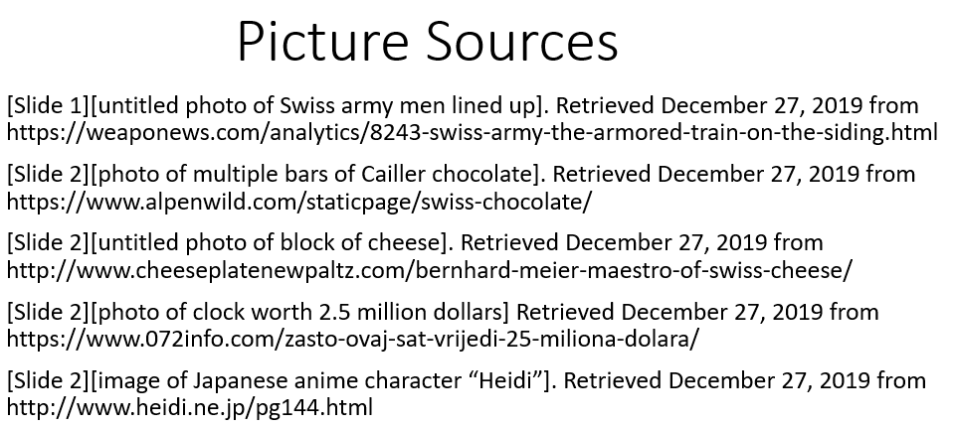

Example of slide referencing information and quotation sources:

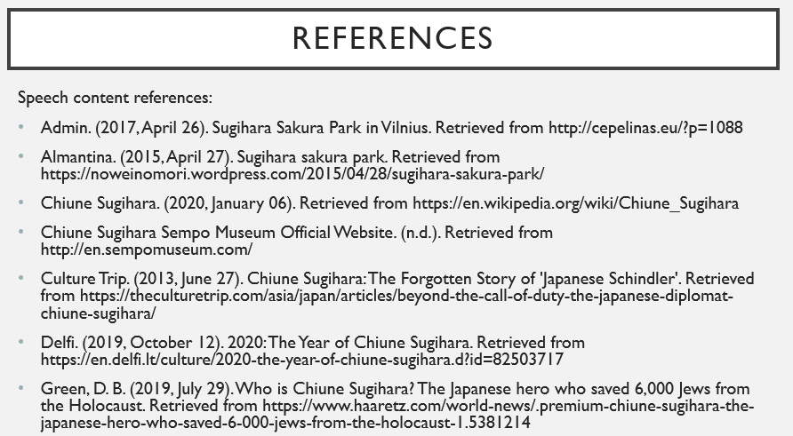

For more information on APA Referencing, please see the websites below:
http://libraryguides.vu.edu.au/apa-referencing/getting-started-in-apa-referencing
https://www.ukessays.com/referencing/apa/
http://www.bibme.org/citation-guide/apa/

If you have any questions, please contact speechcontest@jpf.org.uk

The 18th Japanese Speech Contest
for University Students

2. Group Presentation Category Application Form
This application form is only for those applying for the Group Presentation Category.
If you would like to apply for the Speech Category or Individual Presentation Category,
please download the relevant application form from https://jpf.org.uk/whatson.php#1235 or https://www.batj.org.uk/en/speechcontest.html

Group details:
University name:
Group name: | (You are free to choose your own group name, but please choose a name in Japanese if possible)
Group name in English
(if different from above):
Number of participants: | Two  Three  Four
Presentation Theme: | In Japanese:  In English:  Please write the broad theme that you would like to make your presentation on. If you wish to make minor changes to this theme, please contact us before you submit your video and PowerPoint file by 15:00 on Monday 16th January 2023

Details of Group Member 1:
Please note, this person should be willing to act as the main contact point for the group.
Title (Mr, Ms, etc.):
First name(s):
Surname:
First name(s) in katakana:
Surname in katakana:
First Language:
E-mail address:
Mobile number:
Term-time address:
Name of Degree Course:
Year of degree course: | year
Name of Japanese course(s) enrolled on:
Name of main Japanese course tutor:
Course tutor’s e-mail:
Total time spent in Japan since the age of six:  : | years months
Name(s) of all textbook(s) used on your Japanese course, between now and 16th January 2023.
Application form continues on next page

Details of Group Member 2:
Title (Mr, Ms, etc.):
First name(s):
Surname:
First name(s) in katakana:
Surname in katakana:
First Language:
E-mail address:
Mobile number:
Term-time address:
Name of Degree Course:
Year of degree course: | year
Name of Japanese course(s) enrolled on:
Name of main Japanese course tutor:
Course tutor’s e-mail:
Total time spent in Japan since the age of six:  : | years months
Name(s) of all textbook(s) used on your Japanese course, between now and 16th January 2023.

Details of Group Member 3 (if applicable):
Title (Mr, Ms, etc.):
First name(s):
Surname:
First name(s) in katakana:
Surname in katakana:
First Language:
E-mail address:
Mobile number:
Term-time address:
Name of Degree Course:
Year of degree course: | year
Name of Japanese course(s) enrolled on:
Name of main Japanese course tutor:
Course tutor’s e-mail:
Total time spent in Japan since the age of six:  : | years months
Name(s) of all textbook(s) used on your Japanese course, between now and 16th January 2023.

Details of Group Member 4 (if applicable):
Title (Mr, Ms, etc.):
First name(s):
Surname:
First name(s) in katakana:
Surname in katakana:
First Language:
E-mail address:
Mobile number:
Term-time address:
Name of Degree Course:
Year of degree course: | year
Name of Japanese course(s) enrolled on:
Name of main Japanese course tutor:
Course tutor’s e-mail:
Total time spent in Japan since the age of six:  : | years months
Name(s) of all textbook(s) used on your Japanese course, between now and 16th January 2023.

Please tick after reading our privacy notice (https://www.jpf.org.uk/download/Privacy%20Policy.pdf ):

We confirm that we have read the eligibility criteria and that we are qualified to enter the contest.
We confirm that our presentation will be our own work.
We give our consent for any photographs or videos taken of us during the contest to be used by the Japan Foundation, BATJ and sponsors of the University Speech Contest for publicity purposes, including making photos/videos available to the public via the internet.

Names of Applicants: 1)
2)
3) (if applicable)
4) (if applicable)

Date:

This form can be downloaded from www.jpf.org.uk/language or www.batj.org.uk.
For all enquiries, please e-mail speechcontest@jpf.org.uk

The 18th Japanese Speech Contest
for University Students

3. Tutor Confirmation Form
(To be completed and returned by the course tutor
named in the above application)

How to complete this form:

1. The applicant informs their main course tutor(s) for Japanese that they intend to enter the 18th Japanese Speech Contest for University Students, and makes the tutor(s) aware that they must complete this Tutor Confirmation Form to ensure the entry is accepted.

2. Applicants send this form to speechcontest@jpf.org.uk, and carbon copy (CC) in all course tutors for Japanese named in the application.

3. Course tutor(s) review the details of the applicants that have referred them and tick the confirmation below.

4. Course tutor(s) return the completed form by email to speechcontest@jpf.org.uk

Please note that this application will not be completed until we received this completed confirmation form by email directly from all course tutors referred to in the application.

To the Japanese course tutor(s) of the applicant named in this document:
Please complete and return this form as soon as possible and by Wednesday 14th December 2022 to ensure that your student’s application is accepted.

First name:
Surname:
Position:
University:
Name of student(s):
Please tick after reading our privacy notice (https://www.jpf.org.uk/download/Privacy%20Policy.pdf ):
I confirm that I am the main Japanese tutor of the relevant applicant(s) named in this application.
I confirm that to the best of my knowledge, all details supplied by the above applicant(s) are correct.
I confirm that I have read the eligibility criteria, and that the applicant(s) named here meet the eligibility criteria for their chosen category to the best of my knowledge.
Date:

The 18th Japanese Speech Contest
for University Students

4. Checklist for Applicants
(for applicants’ own personal use)

During the application process, please double-check the following task checklist. Please tick off each task once it is complete. You can use this checklist to track the progress of your application.

You have checked your eligibility for the Group Presentation Category.

All your contact details and university course details are correct.

You have included all details about previous visits to Japan.

You have correctly given all name(s) of all textbook(s) used on your Japanese course, between now and the video submission deadline of 15:00 (GMT) on Monday 16th January 2023.

You have returned the application form by email before 15:00 (GMT) to speechcontest@jpf.org.uk on Monday 12th December 2022. You have CCed in all course tutors named in the application form.

All course tutors for all applicants in this category have been informed that you are applying for the contest, and that they are aware that they must submit a confirmation form in order to complete your application by Wednesday 14th December 2022.

You have received a confirmation email from the Japan Foundation (speechcontest@jpf.org.uk) within 3 working days of sending your application (if you do not receive this email, please contact the Japan Foundation on speechcontest@jpf.org.uk)

We encourage you to apply at least one week before the deadline to ensure that any potential problems with your application can be resolved before the deadline.

Good luck!

