The Eleventh Japanese Speech Contest for University Students

Group Presentation Category
Application Form and Guidelines

Contents

1. Application Form Guidelines

2. Group Presentation Category Application Form

3. Tutor Confirmation Form

4. Checklist for Applicants

This application form is only for those applying for the Group Presentation Category. If you would like to apply for the Speech Category or Individual Presentation Category, please download the relevant application form from www.jpf.org.uk/language.

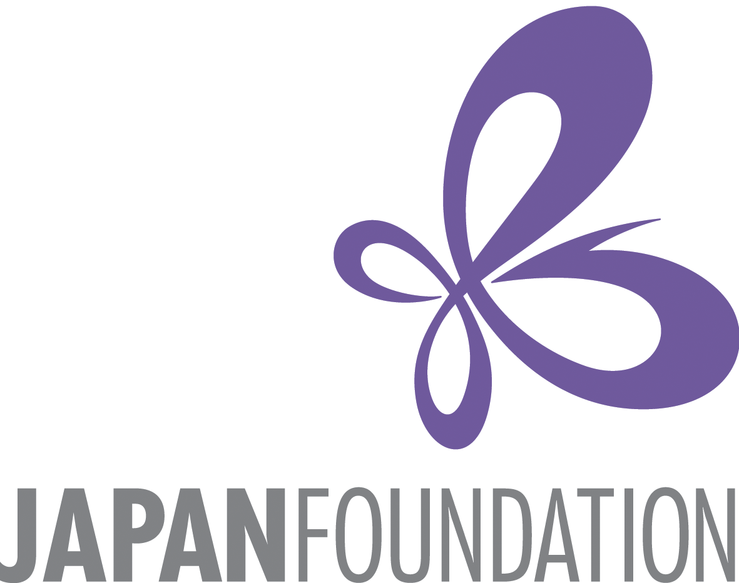
The Eleventh Japanese Speech Contest for University Students

1. Group Presentation Category Application Form Guidelines
Instructions:

- Please complete the application form below, including details of all group members. Send your completed application form in Microsoft Word format (.doc or .docx) by e-mail to info.language@jpf.org.uk before midnight on Tuesday 1st December 2015, with a carbon copy (CC) to all Japanese tutors named on this form (please inform your tutor(s) that you will be doing so).
- Your tutor(s) must then complete the Tutor Confirmation Form and return it to info.language@jpf.org.uk in order for your application to be valid. Please inform your Japanese tutors in advance that you are planning on entering the contest, and that they will be asked to confirm your eligibility. Your application will only be accepted after your tutors have confirmed the eligibility of all group members.

Eligibility for the Group Presentation Category:

This category is open to groups of undergraduate students who meet the following criteria:
- All applicants are enrolled in a Japanese course at a university (degree course or non-degree course) which uses a beginner level Japanese textbook. Your course must use a beginner level textbook up until the time of the video submission deadline (21st January 2016). If you are unsure which textbooks you will be using, please consult your Japanese tutors. Examples of beginner level textbooks: 『みんなの日本語Ⅰ＆Ⅱ』 (Minna no Nihongo – 1 & 2); 『げんきⅠ＆Ⅱ』 (Genki – 1 & 2); Japanese for Busy People – 1 & 2
- Each group must contain between two and four students who are studying at the same university.
- Those who have spent a total of three months or more in Japan since the age of six are not eligible.
- Postgraduate students are not eligible.
- Candidates with Japanese parents are welcome to apply.

If you are unsure if you are eligible for this category, please contact info.language@jpf.org.uk, specifying the name of your degree course, Japanese course, university, and the name of the Japanese textbook(s) you will be using between now and the time of the video submission deadline (21st January 2016).

Presentation Details:

- Presentations should be given in Japanese and last 7-10 minutes per group. Each group member should speak for roughly the same amount of time.
- There will be no questions after the presentation.
- The theme of the presentation should be an introduction to something from the U.K. or another country outside of Japan. It is fine to include Japan for comparative purposes or as a minor part of your presentation; however, the main focus of your presentation should be on something from a country outside of Japan.
- The audience will include native speakers of Japanese and those learning Japanese as a foreign language. We recommend that you choose a theme (e.g. a particular region, event, custom, etc.) that will appeal to this audience.
- When making your group presentation you may only use beginner level grammar and sentence structures – i.e. those that you have learnt in your beginner level course.
- Your final presentation must be made in Microsoft PowerPoint format. Other formats will not be accepted.
- When you submit the presentation video, please be aware that this is your final and completed version, which will be presented to the selection panel of judges.
- The video should contain the presentation of the group of presenters and the PowerPoint slides on the same screen.
- You may not include any video clips or other moving images in your presentation.

Schedule:
Deadline for submitting this application form: Before midnight, Tuesday 1st December 2015
Deadline to record and submit a video of your presentation: 21st January 2016. You must submit the following two items. (Detailed instructions on how to submit these will be given after you apply).
- a digital video recording of your group giving its presentation.
- the presentation itself, as a Microsoft PowerPoint file.
Notification of result: Early February 2016
Groups who demonstrate excellent presentations will be invited to give their presentations at the speech contest finals. All groups will receive feedback on the PowerPoint presentation and video recording that they have submitted as part of their application.
Speech Contest Finals: Saturday 27th February 2016 at SOAS University of London. Speeches and group presentations will take place in the afternoon. This will be followed by the award ceremony in the early evening, and a reception in the evening.
This form can be downloaded from www.jpf.org.uk/language or www.batj.org.uk. For all enquiries, please telephone 020 3102 5021 or e-mail info.language@jpf.org.uk.
The Eleventh Japanese Speech Contest
for University Students
2. Group Presentation Category

Application Form
This application form is only for those applying for the Group Presentation Category. If you would like to apply for the Speech Category or Individual Presentation Category, please download the relevant application form from www.jpf.org.uk/language.

Group details:
University name:
Group name: | (You are free to choose your own group name, but please choose a name in Japanese if possible)
Group name in English
(if different from above):
Number of participants: | Two  Three  Four
Presentation Theme: | In Japanese:  In English:  Please write the broad theme that you would like to make your presentation on. If you wish to make minor changes to this theme, please contact us before you submit your video and PowerPoint file by 21st January 2016.

Details of Group Member 1:
Please note, this person should be willing to act as the main contact point for the group.
Title (Mr, Ms, etc.):
First name(s): |  | Surname:
First name(s) in katakana: |  | Surname in katakana:
First Language: |  | Mobile number:
E-mail address:
Term-time address: | Address line 1:
Term-time address: | Address line 2:
Term-time address: | Address line 3:
Term-time address: | Address line 4:
Name of Degree Course: |  |  |  | Year of degree course:
Name of Japanese course(s) enrolled on:
Name of main Japanese course tutor:
Course tutor’s e-mail:
Total time spent in Japan since the age of six:  : | years months
Name(s) of all textbook(s) used on your Japanese course, between now and 21st January 2016.

Application form continues on next page

Details of Group Member 2:
Title (Mr, Ms, etc.):
First name(s): |  | Surname:
First name(s) in katakana: |  | Surname in katakana:
First Language: |  | Mobile number:
E-mail address:
Term-time address: | Address line 1:
Term-time address: | Address line 2:
Term-time address: | Address line 3:
Term-time address: | Address line 4:
Name of Degree Course: |  |  |  | Year of degree course:
Name of Japanese course(s) enrolled on:
Name of main Japanese course tutor:
Course tutor’s e-mail:
Total time spent in Japan since the age of six: | years months
Name(s) of all textbook(s) used on your Japanese course, between now and 21st January 2016

Details of Group Member 3 (if applicable):
Title (Mr, Ms, etc.):
First name(s): |  | Surname:
First name(s) in katakana: |  | Surname in katakana:
First Language: |  | Mobile number:
E-mail address:
Term-time address: | Address line 1:
Term-time address: | Address line 2:
Term-time address: | Address line 3:
Term-time address: | Address line 4:
Name of Degree Course: |  |  |  | Year of degree course:
Name of Japanese course(s) enrolled on:
Name of main Japanese course tutor:
Course tutor’s e-mail:
Total time spent in Japan since the age of six: | years months
Name(s) of all textbook(s) used on your Japanese course, between now and 21st January 2016

Details of Group Member 4 (if applicable):
Title (Mr, Ms, etc.):
First name(s): |  | Surname:
First name(s) in katakana: |  | Surname in katakana:
First Language: |  | Mobile number:
E-mail address:
Term-time address: | Address line 1:
Term-time address: | Address line 2:
Term-time address: | Address line 3:
Term-time address: | Address line 4:
Name of Degree Course: |  |  |  | Year of degree course:
Name of Japanese course(s) enrolled on:
Name of main Japanese course tutor:
Course tutor’s e-mail:
Total time spent in Japan since the age of six: | years months
Name(s) of all textbook(s) used on your Japanese course, between now and 21st January 2016.

Please tick:

We confirm that we have read the eligibility criteria and that we are qualified to enter the contest.
We confirm that our presentation will be our own work.
We give our consent for any photographs or videos taken of us during the contest to be used by the Japan Foundation and BATJ for publicity purposes, including making photos/videos available to the public via the internet.

Names of Applicants: 1)
2)
3) (if applicable)
4) (if applicable)

Date:

This form can be downloaded from www.jpf.org.uk/language or www.batj.org.uk. For all enquiries, please telephone 020 3102 5021 or e-mail info.language@jpf.org.uk.

The Eleventh Japanese Speech Contest
for University Students

3. Tutor Confirmation Form
(To be completed and returned by the course tutor
named in the above application)

How to complete this form:

1. The applicant informs their main course tutor(s) for Japanese that they intend to enter the Eleventh Japanese Speech Contest for University Students, and makes the tutor(s) aware that they must complete this Tutor Confirmation Form to ensure the entry is accepted.

2. Applicants send this form to info.language@jpf.org.uk, and carbon copy (CC) in all course tutors for Japanese named in the application.

3. Course tutor(s) review the details of the applicants that have referred them and tick the confirmation below.

4. Course tutor(s) return the completed form by email to info.language@jpf.org.uk

Please note that this application will not be complete until we received this completed confirmation form by email directly from all course tutors referred to in the application.

To the Japanese course tutor(s) of the applicant named in this document:
Please complete and return this form as soon as possible to ensure that your student’s application is accepted.

First name:
Surname:
Position:
University:
Name of student(s):
I confirm that I am the main Japanese tutor of the relevant applicant(s) named in this application.
I confirm that to the best of my knowledge, all details supplied by the above applicant(s) are correct.
I confirm that I have read the eligibility criteria, and that the applicant(s) named here meet the eligibility criteria for their chosen category to the best of my knowledge.

Date:

The Eleventh Japanese Speech Contest
for University Students

4. Checklist for Applicants
(for applicants’ own personal use)

Before submitting your application, all applicants should double-check the following:

You have checked your eligibility for the Group Presentation Category.

All your contact details and university course details are correct.

You have included all details about previous visits to Japan.

You have correctly given all name(s) of all textbook(s) used on your Japanese course, between now and the video submission deadline of Thursday 21st January 2016

All course tutors for all applicants in this category have been informed that you are applying for the contest, and that they are aware that they must submit a confirmation form in order to complete your application.

You have returned the application form by email, and have CCed in all course tutors named in the application form.

You return the application form before midnight to info.language@jpf.org.uk on 1st December 2015.

You have received a confirmation email from the Japan Foundation (info.language@jpf.org.uk) within 3 working days of sending your application (if you do not receive this email, please call the Japan Foundation on 020 3102 5021 )

We encourage you to apply at least one week before the deadline to ensure that any potential problems with your application can be resolved before the deadline.

Good luck!

