Teaching primary Japanese:
the Australian experience

Anne Rajakumar
South Wolds Community School and Language College

Introduction
Over the last fifty years the relationship between Australia and Japan has gone from strength to strength. Japan is Australia’s largest trading partner and the third largest source of direct investment in the country. Over the years, the Australian-Japanese economic partnership has blossomed to become a multifaceted relationship including a rich cultural exchange involving scholars, teachers, students, researchers, artists, athletes, journalists, and others. At the same time, Australia’s identity has evolved from one accepting the ‘White Australia Policy’ to one where Australia’s multicultural society is acknowledged and celebrated.

Reflecting the growth in economic and cultural ties between Japan and Australia, the teaching of Japanese in Australia has grown from a handful of schools in the 1980s, to one of the most widely taught languages in the country. Following the adoption of the National Asian Languages and Studies in Australian Schools (NALSAS) Strategy in 1994, in which Japanese was identified as one of four priority Asian languages to be studied at schools, enrolments in Japanese increased dramatically. By 1998 Australia had more than 300,000 pupils learning Japanese, and there were more than 3,000 Japanese teachers; a situation prompting the use of the Japanese word tsunami to describe the increase in numbers of students and teachers. ⁽¹⁾

Primary level ‘Languages other than English’ (LOTEs) were first actively introduced in Australia in the mid 1990s, and from the outset, due to its enormous popularity at senior levels, Japanese has been one of the major languages of the more than forty LOTEs offered in Australian primary schools. LOTE has now become an established part of the curriculum of many primary schools with 1,311 schools in 2001 offering Japanese at primary level. ⁽²⁾

The Australian experience in teaching primary Japanese provides a valuable opportunity to examine a long-standing primary Japanese programme operating in a similar educational culture to the UK; and to learn from the successes and failures of the many Australian models of Japanese language education, as we develop our own primary Japanese programmes in this country.

Education in Australia

Australia consists of eight states and territories, each of which has its own local education department responsible for developing educational policies within its state or territory. Whilst each region operates independently, the national government is able to target funds to implement defined educational initiatives, resulting in a level of consistency in educational policy Australia-wide.

Throughout the country education is compulsory to the age of 15. State government schools comprise approximately 70%, Catholic schools 20%, and independent schools 10% of the total number of schools in Australia. At the tertiary level, all institutions but one are government-funded.

Australian primary schools start with an optional Preparatory (Prep)/Kindergarten year, then pupils progress from Year 1 to 6 in most states (some are 1 to 7), while secondary schools usually begin in Year 7 and end in Year 12 (Year 8 – 12 in some states).

Given the number of state and territorial education departments, and the diversity within the systems at a state and territorial level, there is a great deal of variation in Australian schools in school structure, curriculum content, teaching styles, and choice of subjects. With a myriad of languages taught, including Aboriginal languages, European and Asian languages, LOTE is an area where diversity is particularly encouraged and flourishes.

Although many states have adopted a curriculum framework, these documents are mostly general in nature, and allow each school to develop their own distinctive programmes. The most prescriptive curriculum outline is produced by the NSW Department of Education and the Japanese Syllabus is attached as Appendix 1.

Primary LOTE

Between 1987 and 1994 each state and territory government endorsed strategies to promote the introduction of LOTE at primary level, and in line with the National Asian Languages and Studies in Australian Schools (NALSAS) Strategy, Japanese was one of the most widely introduced languages. Targets for the introduction of LOTE at primary level ranged from an immediate requirement to offer a LOTE to every primary pupil in South Australia; to New South Wales, where schools were directed to give every primary pupil an entitlement to LOTE tuition by 2010.

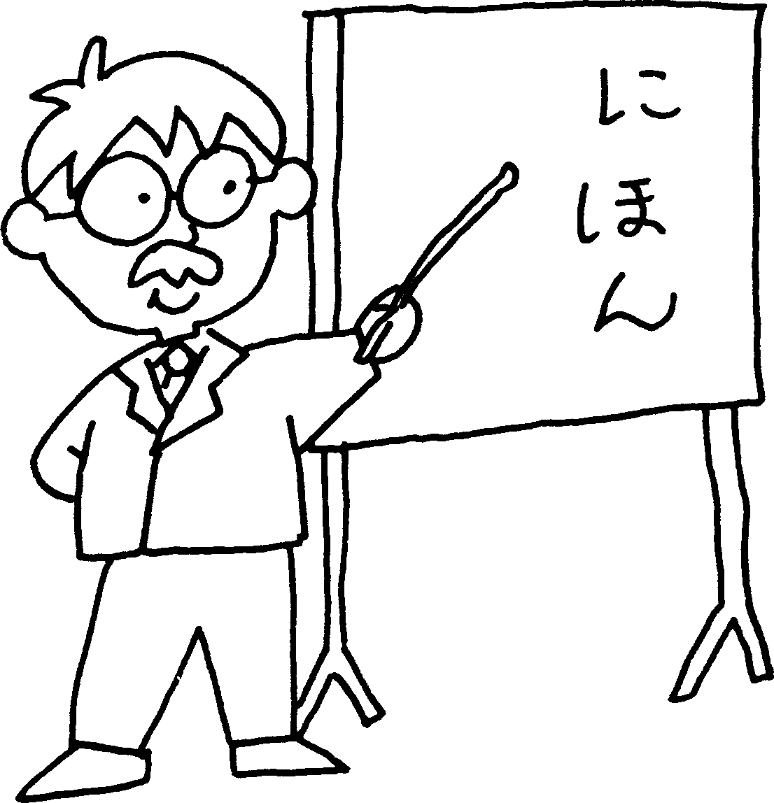

Primary Japanese in Victoria

Because of the difficulty of gathering detailed information from each state, this study will focus on the teaching of primary-level Japanese in the South-eastern state of Victoria, where Japanese was identified as one of the eight key languages in the Languages Other Than English (LOTE) Strategy Plan which was launched in October 1993. The major recommendation of the LOTE Strategy Plan was to provide all students in Years P-10 (Reception to Year 10) and 25% of Year 11-12 students with LOTE programs by the year 2000, and to achieve this by staged implementation.

By 2001, approximately 20% of primary pupils in Victoria were studying Japanese (55,000 pupils) as their designated LOTE, which made Japanese the third most widely studied LOTE after Indonesian (29.7%) and Italian (28.2%)(1). The following table charts the growth of Japanese from 1994, shortly after it was introduced, to 1997. ⁽⁸⁾
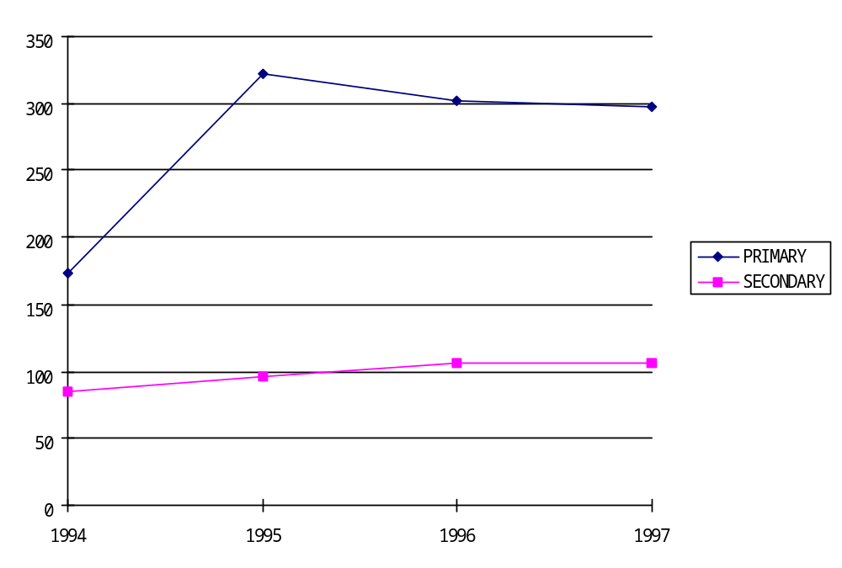
Number of schools teaching Japanese
We can assume that these numbers would be fairly similar today, as there have been no major policy changes regarding primary LOTE since 2001, and the
number of schools teaching Japanese has stabilised over the years.
The information in this report has been gathered using published statistics supplemented with responses to a number of questionnaires, which were emailed to primary Japanese teachers through the Victoria email network (Nihongo-Victoria@yahoogroups.com - See Appendix 2), as well as the personal experiences of the author.

Contact Time

The time spent in Victorian schools in 2001 by primary pupils engaged in second language learning ranged from 15 minutes per week at one extreme, to 25 hours per week at the other. The average time spent on LOTE learning was just over one hour per week, divided into a number of shorter lessons according to the timetable requirements of each individual school. ⁽¹⁾

Many teachers of both Japanese and other languages argue for a greater time allotment, however schools in Victoria are increasingly suffering from a ‘crowded curriculum’, and there is a lot of competition from other subject areas for a greater time allotment within the school timetable. In addition, parents and governments are increasingly concerned about the falling standards in numeracy and literacy, and these basic subjects have seen a growth in their relative importance in the school curriculum.

Program Type

LOTE programmes in primary schools can be broadly classified as object based, where the focus is on the teaching and learning of the target language; content based, where a significant portion of the wider school curriculum is taught in the target language; or as language and cultural awareness programmes, where a limited vocabulary and aspects of culture and society are introduced. The aims of the programmes and the teaching methods used differ according to the programme adopted.

Object-based Programmes

The largest number of students studying Japanese in Victoria is in object-based programmes. The communicative approach to second language learning, whereby pupils are encouraged to use the target language to complete meaningful and varied tasks, is the norm; and all four skill areas of listening, speaking, reading and writing are included in most courses. Although each school is free to develop their own specific syllabus, and programmes differ markedly from school to school, they generally follow a similar progression through language topics, beginning with topics linked with self and family, and then widening to include local communities and familiar locations. Almost invariably, hiragana is introduced very early in the course, followed by the introduction of katakana and kanji as the pupils progress to senior levels. Most teachers introduce hiragana and katakana using mnemonics based on the Hiragana in 48 Minutes system, but as these were developed for adult learners, they are usually modified somewhat for primary pupils. The use of the English script (romaji) to write Japanese is frowned upon by the Australian Japanese teaching community in general, and very few schools use romaji in anything other than a very limited way. As the pupils are very young, teachers tend to employ a mix of games, songs, stories, craft activities and guided reading and writing tasks to teach the language. The curriculum is developed using the Victorian Curriculum and Standards Framework II (CSFII) as a guide – see Appendix 3 for an overview of this document.

Object-based programmes delivered by teachers

Most object-based programmes are delivered by qualified teachers in a conventional classroom setting with an average contact time of 100 minutes per week. ⁽¹⁾ In the primary system, specialist subjects such as Art, Music, Physical Education, English as a Second Language (ESL) and LOTE are taught by specialist teachers who take responsibility for a class for the duration of their lesson. This provides classroom teachers with valuable non-contact time when they can attend to other tasks such as preparation, marking and administration.

Sometimes classroom teachers are encouraged to attend the Japanese lessons
so as to be able to reinforce the Japanese language outside designated lesson time. However, this rarely happens as classroom teachers are usually too busy.

Occasionally Japanese is taught by a classroom teacher with a time allocation to teach other classes Japanese, but generally a specialist teacher will be employed specifically to teach Japanese. Due to budgetary constraints, smaller schools often share a specialist Japanese teacher with other small primary schools in their local area.

The use of volunteer Japanese native speaker teacher assistants (interns) in Australia is widespread, and occasionally these volunteers from Japan teach a Japanese programme with the help of the classroom teacher. As these assistants are rarely trained teachers, this situation is far from ideal, and is only resorted to in a limited and informal way when trained Japanese teachers can’t be recruited. Most commonly, volunteer Japanese native speaker teacher assistants join the trained Japanese teacher in the classroom to provide a native language model for the pupils to copy, and to share their knowledge and experience of Japanese culture and way of life. Many formal Japanese courses have been introduced at primary level following the hosting of a volunteer Japanese native speaker teacher assistant, due to the enthusiasm of the children for the language, having been informally introduced to Japanese during the volunteer’s stay at the school.

Case study 1. A successful object-based programme in a state funded school described by Pam Spiegal, Coordinator of Japanese at Malvern Central School
Malvern Central School is a Prep [preparatory – equivalent to reception] to Year 8 school in the suburbs of Melbourne. MCS is one of two remaining government central schools in Victoria. The Japanese program began in 1995. The students began Japanese in Prep and Year 1 that year and there was already a French program in Year 7 & 8. At the end of that year the French teacher retired and it was decided to take Japanese right through the school. We then hired a second Japanese teacher. We recruited our teachers through the

‘Education News’ and full interviews took place at the school with a
panel of 4 members to interview the teachers, parts of the interviews were conducted in Japanese to check the competency of the applicants.
The parents are very supportive of the Japanese program. Our school has a Friends of LOTE Japanese committee for parents to help with the Japanese program. They assist with our exchange program with our sister school, school fetes and our ICT program. There are approximately 615 students at our school and they all participate in the Japanese program. Japanese is a compulsory core subject at our school. I teach year Prep to 4 and the other Japanese teacher, Diane Eddey teaches Year 5 to Year 8. Our school runs on a two-week cycle timetable, the students have three hours of Japanese a cycle.
Our students can continue their Japanese at senior high school depending which High School they choose to attend. Our students go to over 15 different schools when they leave our school so transition to high school is difficult to coordinate. Many go onto private schools in the area some of which teach Japanese. I do coordinate the program with my colleague, Diane Eddey, in Middle school. Our program is planned together so that we can have some continuity.
In the lower primary part of the school we try to integrate when applicable, but it is a little harder in the senior part of the school. The students begin learning using hiragana from as early as prep. They are given whole word recognition rather individual hiragana. In Year 1 they begin learning hiragana in earnest. By year 2, they know 46 hiragana, both written and orally, and are able to put letters together to form words. In year 3 & 4 it is expected that they will pick up the rest of hiragana. In Year 5 & 6 they begin learning katakana. Kanji is taught when applicable from Prep to Year 8.
By year 6 the students are able to introduce themselves, say their name, age, discuss likes and dislikes and say where they live. When counting, depending on what they are counting, they are taught applicable counters. The children cover a broad band of topics

including, greetings, numbers, colours, family members, weather, shopping school subjects and stationery requirements, likes, dislikes, hobbies, sports and housing etc.
We have a sister school arrangement with Monou Cho in Miyagi Prefecture in Japan. The students from that school visit us every year in August and this year was to be the first time we were to go there, however due to the world situation, the school council and the Principal felt the trip needed to be cancelled. We are hoping to try again next year. We have a second arrangement with Horifuna Primary School in Tokyo and we are doing video conferencing with them in real time, which has been an amazing experience for the students. This is followed up with written work in the form of experiences written and sent to the other school in a book form.
Both the students and school are committed to the Japanese program and we are always looking to make it bigger and better. The major strengths of the program are that we have dedicated teachers who are working together to provide the best program possible for the students. We feel our program is both fun and educational for the students. Our use of Information Communications and Technology has enhanced our program greatly. We have in the past used volunteer Japanese Native Assistants to help in our program and they enhance the program and they lend an authenticity to the language and culture of the program.

Case study 2. A successful object-based programme in a state funded school, described using the questionnaire responses by Tanya Radda of Waverley Meadows Primary School
Japanese was introduced at Waverley Meadows Primary School in Melbourne as an after school programme in 1995, due to community interest in the language. It is currently taught from Prep (equivalent to

reception year) to Year 6 for 1 hour per week, using the Niko Niko Ideas book 1-4, the Yonde Kaite Workbooks 4 and 5, and the teacher’s own worksheets.
Hiragana is introduced from the start and is always included in worksheets for the pupils to trace, even with the youngest pupils. Katakana is only used for the children’s names, and the kanji numbers from 1 – 10 are taught from the prep year. Romaji is never used, except as labels in the Yonde Kaite workbooks.
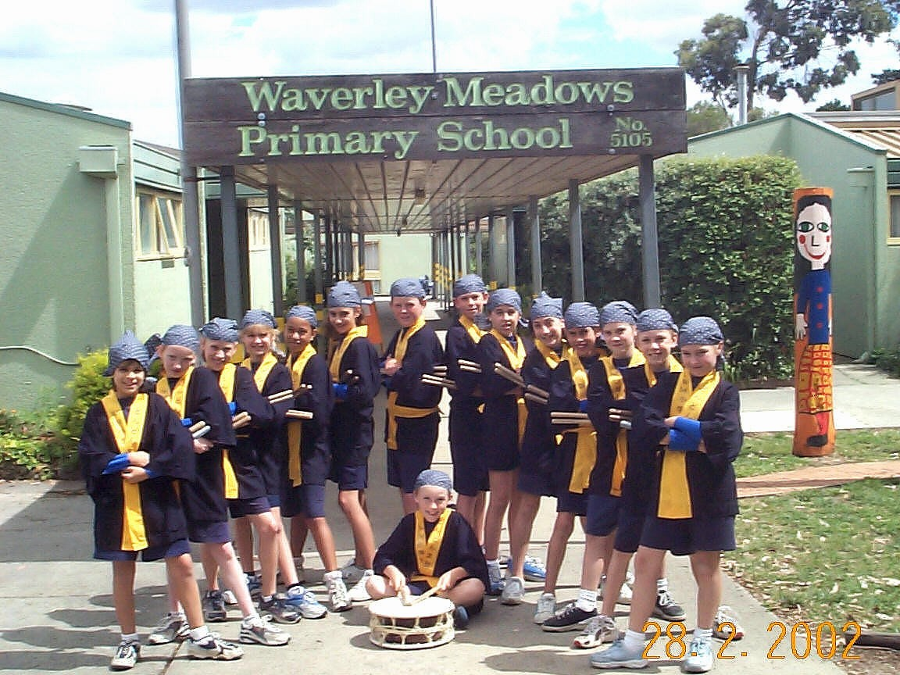
There is one Japanese teacher, however many Japanese visitors are invited to the school, and a group of Junior High School pupils are hosted annually from Japan. The teacher is a non-native speaker of Japanese without formal Japanese qualifications. The school previously had difficulties with native speaking teachers who found maintaining class control in Australian classrooms very difficult.
The school’s taiko group, 'Don Don Daiko', was formed in 1999 as part of their Japanese programme. The original 15 students knew little about the art of TAIKO [Japanese drumming], but their enthusiasm and determination to learn kept the group together, and ensured their rapid development. As authentic TAIKO was far beyond the budget of the group, plastic rubbish bins and rubber tyres were used for practice. In 2001 the group received a government grant, which enabled them to buy locally made TAIKO. Over the last 2 years, 'Don Don Daiko' has participated in a variety of concerts and Japanese festivals. Not only has this helped them develop a sense of achievement and self-respect, but it has also exposed them to many

new and enriching life experiences! The Japanese language programme has been especially well received by the parents at the school due to the high profile of the Taiko group, and hopes to continue their programme in the future, possibly with the addition of a Japanese volunteer native speaker assistant.
Problems that have been experienced at this school, include the negative change in the attitude of the Year 6 pupils when they realise that they cannot continue Japanese in year 7 at high school; integrating pupils whose native language is not English; funding for excursions; and helping pupils retain their knowledge of Japanese with only one period of Japanese per week.

Object-based programmes delivered via technology

In order to provide LOTE programmes to isolated and rural areas which have traditionally had great difficulty recruiting teachers in a climate of severe teacher shortages, distance-learning, using a variety of visual and audio links such as satellite programmes, video conferencing, computer, facsimile and telephone links was introduced nationwide.
In Victoria, the Primary Access to Languages via Satellite (PALS) and Secondary Access to Languages via Satellite (SALS) programs were launched in 1994 to allow schools, particularly those in country Victoria, to implement a LOTE program or to complement existing programs. As both LOTE teacher availability and language proficiency have improved, there has been a dramatic shift away from such programmes, and they are now generally used for enrichment and extension purposes only. Anecdotal evidence suggests that programmes offered without a teacher to enthuse and engage the pupils quickly lose momentum and are eventually discontinued completely.
The table below illustrates the trend in Victorian schools participating in the Japanese satellite broadcasts. ⁽⁸⁾

1994 | 1995 | 1996 | 1997 | 1998
144 | 308 | 217 | 143 | 93

Content-based Programmes

Content-based programmes are often called bilingual programmes and account for only 0.5% of pupils studying Japanese at primary level.⁽¹⁾ The average time allocated to Japanese in such programmes is approximately 10 hours per week, which is spent in the study of the target language itself, as well as a variety of other subjects such as SOSE (Studies of Society and the Environment) and Physical Education through the medium of the target language. Although the numbers involved in content-based Japanese learning are relatively small, the bilingual schools have a high profile and are popular amongst pupils and parents. The level of proficiency the pupils attain in the target language is very high, which encourages a feeling of success and achievement in the children.

Problems faced by schools embracing a bilingual programme include the recruitment of appropriately skilled teachers, and the development of materials and course content in isolation from other schools teaching Japanese.

Case study 3. A successful content-based programme in a state funded school described using the questionnaire responses Kylie Farmer, Coordinator of Japanese at Huntingdale Primary Bilingual School

During 1997 the Victorian Department of Education initiated the Bilingual Schools Project. Huntingdale Primary was renowned for its Japanese LOTE program and successfully applied to take part in this exciting project. Since then the program has expanded and developed to become a very successful Japanese bilingual program.
All children from Prep - Grade 6 [Reception to Year 6] at Huntingdale Primary are involved in the bilingual program. When the program began the school had approximately 90 students, and currently enrolments are at approximately 150. The increase in enrolments has been largely due to the successful bilingual program as well as the effective literacy and numeracy programs offered at the school.

Each week students have 450 minutes taught in Japanese. This includes 150 minutes of LOTE (language instruction linked to themes)

and 300 minutes of content-based classes. These are 1 hour each of Music, Art, Science, SOSE (Studies of Society and the Environment) and PE each week. These Key Learning Areas are taught entirely in Japanese with the bilingual staff responsible for the planning, implementation and assessment of all aspects of the subject area. SOSE is the only subject which is shared, with some aspects covered in English and some in Japanese – this involves careful planning to ensure there is no overlap and that all outcomes are split appropriately between English and Japanese.
Recruiting teachers is a very important aspect of a successful program. It is recognised worldwide that bilingual programs have a high staff turnover due to the intensive nature of the programs - there are minimal resources and therefore a lot of work for teachers to prepare and teach content-based lessons. We have been very fortunate to have had one staff member who has been with the program since it began in 1997. We have also trained many teachers through university placement programs and some of these teachers have come back to work with us after graduating. We have found it works best when the content-area subjects are taught by native speaking Japanese teachers - largely due to the fact that the language required to teach these areas is quite specific and complex. LOTE is currently taught by myself and another non-native LOTE teacher. We are actually classroom teachers and spend approximately 5 hours a week teaching LOTE. The rest of the week we are teaching Maths, English and so on, in English. It works well having classroom teachers as part of the bilingual team as it ensures effective communication, planning and understanding between the bilingual team and classroom teachers. It also provides students with a non-native role model and children often use Japanese with us in the classroom outside of the allocated Japanese sessions.

Parents and the school community have been very supportive of the
Japanese bilingual program. Some parents come to the school
specifically because of the program and others are happy that their children have the bonus of learning another language to such a high standard in a well structured program. We hold parent information evenings to inform parents about the unique program Huntingdale offers and the benefits of bilingual education - particularly in relation to the benefits it has for student’s overall linguistic and metacognitive development. Parents are very enthusiastic to host students from our sister school and are also keen to learn Japanese themselves (we have after school classes for parents too!).

When the program began in 1997, unfortunately there wasn't a secondary school program established in the area to provide a Prep - Year 12 [Reception to final year of secondary school] bilingual program in Japanese. As we are a small school and our small number of graduates each year go to a range of different secondary schools, there are only ever 2 - 3 of our students at one school and this of course makes it difficult for secondary schools to run separate programs to cater for the student’s advanced language abilities. Some schools are running separate streams for students who have studied Japanese before, some are provided with extension tasks and others have taken up Year 8 Japanese at the VSL (Victorian School of Languages) after school programs. We provide all of the secondary school LOTE teachers with a copy of the student’s "Japanese Passport" which outlines the bilingual program students have experienced and whether they have been on the school trip to Japan, our immersion camps etc. This gives the teachers insight to the student’s ability and hopefully they can recognise and cater for their language needs.
Our curriculum is based entirely on the Victorian Curriculum and Standards Framework II (CSFII). This is a Prep - Year 10 document and therefore we are able to extend our students into the Year 7 - 8
section of the LOTE curriculum as appropriate. There is currently a
focus on the Middle Years of schooling (Years 5 - 8) and there is more networking between primary and secondary schools to ensure students remain engaged in learning which is creating more opportunities for teachers to liase on a range of issues, including curriculum.
It is difficult to quantify our pupil’s incredible skills, however we do an intensive individual assessment survey which looks at the 4 macro skills and all students tend to be achieving at or above CSFII Level 4 (the expected level for Year 6 students) in reading and writing and at or above CSFII Level 5 (the expected level for Year 8 students) for speaking and listening. Other than the 4 macroskills which are assessed and reported on, we notice students have a number of other skills including: confidence in engaging with Japanese speakers; an understanding and appreciation of the Japanese culture; and recognition of the fact that bilingual education is an excellent means of learning a second language! All students are enthusiastic to continue their Japanese studies and to maintain links with Japan.
Students are able to introduce themselves confidently - this is a skill currently being revisited by the Year 5/6s ready for their trip to Japan where this will be a crucial communication skill. In the area of counting, rather than saying they can count to a certain number, I would have to say they have the skills and knowledge to work out how to say the numbers they need. We do use the range of counters as they occur naturally in our learning and introduce specific counters (eg. hitotsu, futatsu; hitori, futari).

We begin teaching hiragana from Prep [Reception] however we use katakana and kanji when appropriate so children are exposed to the 3 scripts from the beginning. Katakana is then formally introduced from Year 3. We are currently beginning to teach kanji from Year 1 with the
goal of teaching 100 kanji by the end of Year 6. To support student’s
writing we find it is important to develop student’s reading skills. We do this through a take home reading program - children take home a Japanese book and tape each week to listen to and practise reading. Students then bring this back each week and read it to a Japanese volunteer and progress through a levelled set of readers as their skills develop.

Our students don’t follow a typical LOTE curriculum which may cover defined topics such as self, family, and local environment. They do acquire that sort of language, however it tends to come through "real learning" through topics covered in the integrated curriculum. Themes covered are those taught in the English / SOSE curriculum such as Animal Habitats - through this unit the junior students are engaged in "interesting and meaningful" learning and saying things such as "chimpanzees don’t have tails" or "zebras live in Africa". In the senior school (Year 3 - 6) students have been looking at Aboriginals and may say things in Japanese such as "aboriginals use boomerangs to catch food".
We have had a sister school in Japan for many years and we are about to make our 3rd trip to visit Otaki in October this year with 20 Year 5/6 students. This week we will also host 20 students from Otaki so the children have excellent opportunities to interact, develop friendships and use their language skills. We have done a range of exchange projects such as a teddy bear style project where we sent a toy koala with a camera and a scrapbook to our sister school to find out about school and life in Japan.

Our students love learning Japanese! Particularly the older students realise they are fortunate to be able to learn to speak Japanese so well and are very proud of their language achievements. When the students are learning other curriculum areas in Japanese they often
forget that it is in Japanese, as they are so engrossed in the actual
learning and they have only ever learnt, for example Science, in Japanese, so it is a normal part of their school day.

Resourcing is one difficulty as there are very few resources available for bilingual programs. We need content-based materials in Japanese at a level appropriate for our students. Materials from Japan where the content may be age-appropriate tend to have language which is too difficult or vice versa - language is appropriate but content is too easy. As there are very few Japanese bilingual programs operating worldwide, there are limited opportunities to network with other teachers. We were fortunate to have received a Japan Foundation grant last year which enabled us to bring out two leading educators in Japanese bilingual education from the USA for a two day conference. Adequate funding is always a concern. As the program has been successful, our numbers are growing, however our funding for teaching allocation has remained unchanged, thus making it more and more difficult to cover the 7.5 hours a week for each class to be taught in Japanese. Qualified, committed staff are also difficult to come by as mentioned above.
The success of the students is inspirational and incredibly rewarding! To see students who have come to school with only English who are now in Year 4 and are confidently enjoying reading quite complex Japanese story books, or performing a school play entirely in Japanese, is very satisfying as it makes you aware of the heights children can reach when they are supported and encouraged to do so. (Our school motto is "Aim High".)
The annual immersion camp, the Japanese drums workshops and Japanese sports day are highlights of our program as well as, of course, the bi-annual trip to Japan.

We have a number of Japanese volunteer assistants who come to assist us one or two days a week. This is an excellent resource and they are invaluable in helping to create resources, listen to individual children read, and help in group activities. We haven't had interns [volunteer Japanese native speaker teacher assistants] recently as we find it is difficult to find long term home stays for them and we also find we have sufficient help with our fantastic volunteers!
Language and Cultural Awareness Programmes

Approximately one third of primary Japanese programmes in Victoria are language and cultural awareness courses. ⁽¹⁾ These courses were introduced to satisfy the government requirement for some form of LOTE teaching at primary level where qualified Japanese teachers were not available. Volunteer Japanese native speaker teacher assistants from Japan, or non-qualified teachers were able to introduce this kind of programme, and so for a large number of schools it was the only option available to them given the severe shortage of qualified Japanese teachers, particularly in rural and isolated areas. The curriculum focuses on Japanese festivals and traditional cultural pursuits such as tea ceremony and ikebana. Japanese sports are invariably included and Japanese lifestyle is introduced using books, games, videos and IT-based information. A feature of these programmes is often a strong emphasis on craft activities around Japanese themes.

Many of these cultural awareness programmes subsequently developed into successful content-based courses, but there were also schools where this kind of programme was not seen to be achieving substantial educational outcomes and was therefore discontinued.

The following information from a Japanese teacher working just outside Melbourne perhaps sums up the general attitude towards language and cultural awareness programmes:

When I first began my Japanese LOTE lessons in 1994 I taught prep to grade 2 [Year 2] classes at Ferny Creek Primary School in their own classroom once a week for a total LOTE commitment of half a day a week. The rest of the time I was the Library teacher and responsible for transferring the library catalogue to a computerized system. During the next two years an extra year level was introduced to the Japanese Language and Culture course. With the students receiving less than 150 minutes per week Japanese language tuition the program I taught then and am still presently teaching is what the Ministry or Department of Education (depending what the State Government at the time has titled it) has called a Language Awareness program. This is another issue in its own right. Most Primary schools are not prepared to resource LOTE programs to the recommended level of 150 minutes per week. Even if they did there are not the necessary qualified LOTE Teachers to teach LOTE in all the Primary and Secondary schools let alone in dedicated LOTE-specific classrooms with teaching materials and resources to do so.

Funding Primary Japanese

In Victoria, Japanese is currently funded in the LOTE Priority Programs component of the School Global Budget (SGB). This provides $77.25 [£31] per pupil for LOTE programmes, however each school determines independently how it uses its funds. Funds may be used to pay for teacher’s salaries, or to purchase alternative teaching programmes, such as IT-based learning, or PALS satellite broadcasts.

When Japanese was introduced in the 1990’s, the funding for LOTEs by the state government was quite generous. Additionally, schools introducing Japanese could access funds by applying for grants from the Japan Foundation for teaching materials, or state-funded ‘LOTE and Studies of Asia’ grants. The National Asian Languages and Studies in Australian Schools (NALSAS) Strategy also supported the introduction of Japanese Australia wide.

The funding for LOTE since then has remained fairly stable, despite increasing costs of salaries and teaching resources. This has made it difficult to maintain Japanese programmes at a constant level.

One Victorian Principal has provided the following frank overview of the funding of Japanese, and the feelings towards LOTE by primary school administrators:
In the early 90's, LOTE was introduced by government decree and made obligatory as the 8th KLA [Key Learning Area]. A few schools were given specially funded LOTE teacher positions that remain to this day. It was a new entitlement position over the normal staffing ratio. Most schools got nothing to facilitate LOTE initially but teachers were scarce, so in practice it didn't matter.
In about 1994 the Government announced a cash grant of $25 [£10] per student for LOTE, (except for those lucky schools already given a teacher position). This rose to $50 [£20] the next year and $75 [£30] the year after. It was tagged LOTE and meant to be spent on LOTE teaching and resources, but no one ever checked and we didn't need to report on LOTE outcomes.
The funding is still approximately $75 [£30] per head today. As teacher wages have risen, this sum has bought less and less teacher time, compounded in schools with declining enrolments. For a primary school with for example 350 pupils, this was $26,250 [£10,600] per year, or about 0.8 of a full time wage. Today the same money only buys 0.6 of a teacher’s salary. Only large schools could hire a full time teacher, so there was lots of part time work. In really small schools, the total LOTE grant was so small, it couldn't even hire anyone at all. In schools of 25 pupils - the LOTE grant was $1800 [£730] a year or $34 [£14] a week - impractical and still a problem today. It was not / is not conducive to a good career path to encourage quality teachers.
The tagged funding still exists and although almost all primary schools now do some LOTE, it’s mostly ineffective. There is a sweeping inquiry just started into LOTE. A big number of schools would like to drop the whole idea but the government agenda is to continue.

Staffing Primary Japanese

In 1998 there were 3,131 Japanese teachers working in Australian educational institutions ⁽³⁾ , and the following year 201 teachers were identified as teaching Japanese at primary level in Victoria. With the growth of Japanese at secondary and then primary levels, the number of Japanese teachers is well below that necessary to staff Japanese language programmes across the country, especially in rural areas, and many strategies have been implemented to boost teacher numbers.

One strategy has been to encourage teachers already in the system (usually teaching other languages) to retrain as Japanese teachers by completing a regular university course in Japanese or a special Japanese course at tertiary level designed for teachers, or some other type of course. These teachers commenced learning Japanese just prior (occasionally simultaneously) to teaching the language, with some teachers receiving special part-time leave in order to undertake an appropriate course. In a sample of 87 non-native primary teachers in 1994, only 33 (38%) had undertaken at least two or three years of tertiary study of Japanese. Nevertheless 80% of the total were enrolled in a Japanese course of study at the time of the survey, an indication that many teachers perceived the need for further study. ⁽⁴⁾ In 2000, 27 participants took part in NALSAS (National Asian Languages and Studies in Australian Schools) - funded Japanese language courses ⁽²⁾, and in the 2003 Victorian budget, funds have been allocated to boost LOTE education in schools, some of which have been earmarked to retrain rural and regional teachers as LOTE teachers. ⁽⁶⁾
In addition to retraining at a local level, scholarships to Japan were introduced in the 1990s by the Japan Foundation to train non-native primary and secondary Japanese teachers in Japan. Under this scheme, teachers have been sent to Japan on short term and long term programmes for many years, with more than 252 Australian Japanese language teachers participating in courses at the Japan Foundation’s Japanese-Language Institute in Urawa Japan, since 1997. ⁽³⁾ This process continues, with funds provided in the national 2003 budget for in-country fellowships for language teachers. Teachers in all the major languages taught in Australian schools will be eligible for these new fellowships, which will offer teachers an immersion experience in the language, country and culture about which they are teaching. It is anticipated that 120 – 140 fellowships will be available each year and that the first fellowships will be offered in January 2004. ⁽⁷⁾
The JET programme, where university graduates are sent to Japan to teach English in Japanese high schools, has also proved a valuable training ground for future teachers of Japanese. With almost 3,000 Australian university graduates participating in the programme from 1987 – 1999 alone, there have been many Japanese teachers recruited from their ranks in recent years. ⁽³⁾

A further source of Japanese teachers in primary schools has been secondary schools, many of which provided the services of their Japanese teachers to teach Japanese in their local feeder primary schools when primary LOTE was first introduced in the mid 1990s. Teachers who initially taught on this basis often subsequently took permanent positions at these primary schools, which were given special dispensation to employ them, despite these teachers not holding specific primary teaching qualifications.

In 1995 only 14% of primary school teachers were native speakers. ⁽⁴⁾ Although this number has been steadily increasing since then, this is an area that needs to be expanded in the future to provide an appropriate mix of native and non-native speakers in schools, and to redress the shortage of properly trained primary Japanese teachers which remains a significant problem throughout Australia.

Information Technology in Primary Japanese

The use of IT (Information Technology) in Australian primary schools has been a priority area for many years. Schools all have internet connections to allow them to develop on-line relationships with schools in Japan, and video conferencing facilities are becoming commonplace. CD-ROMs are a popular learning resource, with a number of very successful titles being produced in Australia specifically for primary learners. There are many impressive web pages developed by pupils of the Japanese language across Australia, the following being indicative of the kinds of things being developed for the World Wide Web:

http://shokosensei.senet.com.au/
http://www.eps.vic.edu.au/lote/index.htm
http://www.deguchisensei.com/
http://www.leeming.edwa.net.au/lote.htm
http://www.cookps.act.edu.au/class_lote.htm

Primary Japanese Language Teaching Resources

Non-human resources are readily available in Australia and provide excellent support for primary Japanese programmes. As a substantial amount of Japanese-language educational material is produced in Australia, these resources tend to support the Australian Japanese programmes very well. As well as published support materials, Australian teachers of Japanese can also access the excellent facilities of the Japan Foundation, and apply to host a volunteer native speaker teaching assistant.

The Japan Foundation Sydney Language Centre

In 1991 the Sydney Language Centre was established to support Japanese language education in Australia. It provides resource lending facilities and
donation programs as well as professional development in cooperation with the
states. There is also a Japan Foundation adviser in each state who works in the state education departments with the local language consultants.

Volunteer native speaker teaching assistants (interns)
There are a number of organisations, such as International Internship Programs (IIP), which place volunteer native speaking Japanese teaching assistants (interns) in schools throughout the world where Japanese is taught. These volunteers, who tend to be young female university graduates, must be hosted by families in the school community. They stay for periods from 3 – 12 months, during which time they assist the Japanese teacher in class, and introduce Japanese culture and lifestyle to the pupils. No salary is payable by the school to the intern, and the intern pays a small fee to cover living expenses directly to the host family. The school has responsibility for using the interns in a mutually beneficial way, and organising a host family from the school community.

Interns can be a very valuable addition to a Japanese programme. They usually become firm favourites with the children, and are able to provide an insider’s view of Japan - often from the perspective of a young person. From the teacher’s point of view they can be an invaluable resource. However, providing an appropriate host family and ensuring that the interns are happy and usefully engaged can be an excessive amount of work on top of an already heavy workload.

Some schools are guilty of misusing interns, by expecting largely untrained and inexperienced individuals to plan and implement Japanese programmes without any support. This situation can be very stressful for the intern, and rarely produces a satisfactory Japanese programme.

Non-qualified staff

Some Victorian primary schools have thriving Japanese programmes which are staffed by non-qualified teachers who have knowledge of the language or culture
of Japan. These individuals, who are often part of the school community, work together with the classroom teacher to provide Japanese language or cultural awareness programmes. In normal circumstances, non-qualified teachers would not be allowed to teach in state-funded schools, however the government has identified the use of non-qualified teachers as one strategy to cope with the severe shortage of qualified Japanese teachers.

Commercially available teaching resources

An enormous number of primary Japanese resources are available commercially, including workbooks, blackline master activity books, CDs, CD ROMs, storybooks and readers. An overview of these materials is attached as Appendix 4.

Transition from Primary to Secondary Japanese

One of the issues in Japanese education in Australia that inspires continued debate is the transition from primary to secondary programmes. Due to the variety of languages studied at both primary and secondary levels, it is sometimes the case that a student of a particular LOTE is not able to continue their study of that language. When the same language is available, student numbers and timetable constraints sometimes prevent secondary schools from running streamed programmes that cater for prior learners of the language.

Some schools with strong Japanese programmes influence the surrounding feeder schools to adopt Japanese as their primary LOTE, and most secondary schools try to cater for language learners with prior experience by streaming them into a separate class, or providing them with extension material if they are in mixed-background classes.
At Frankston High School, a secondary school just outside Melbourne, the Japanese coordinator described how they cope with the problem:

We have tried several courses which allow for extension/core work, to have a mixture of pre-learned Japanese background students in the same class as beginners - those who've done French, Italian, Indonesian. After all we have 13 main feeder schools, and students from 33 Primary Schools this year alone.

From next year we will be making students choose before they come, so no 'taster year', but full on Japanese or French from 2004. We offer accelerated classes at Year 9 and enrichment classes at Year 10, predominantly taken by students who had a primary school background in Japanese or French/Italian, but also catering for really talented students who learnt from scratch in Year 7... It's the best we can do.

We offer breadth and enhanced classroom activities and cultural perspectives in those classes. Our Year 12 [final year] results are good, and some students enjoy coasting or sharing their knowledge gained from primary school with our other students. The language studied in primary school is not as important as the positive experience, and the comprehension gained about thinking in a different way in another language.

Lessons to be Learnt

There are many excellent primary Japanese programmes running in Victoria, and most teachers describe their teaching in very positive and enthusiastic terms. Object-based and bilingual programmes seem to be the most rewarding for teachers and pupils alike, and additional activities such as communication with sister-schools, visits to Japan, Japanese days and the development of cultural interest groups motivate the children to want to learn.

In order to maintain their learning momentum it is important for pupils to be able
to continue their Japanese language education at secondary level. To facilitate
this, a coordinated approach to primary/secondary Japanese is to be encouraged so that learners have the opportunity to build on their primary skills and avoid boredom and frustration at high school.

Most importantly, it is imperative that funding initiatives to kick-start the introduction of Japanese are maintained, so that excellent programmes can be continued and built upon in the future. A lack of continuing funding has meant that Japanese teachers have not been able to count on employment security and have often been forced to travel long distances to work between a number of small schools, or have been offered part-time employment only. This situation is far from ideal, and does not encourage people proficient in the Japanese language to enter primary Japanese teaching; but rather tempts people in primary Japanese teaching to move to more prestigious and comfortable careers. There are many opportunities for Japanese speakers in the wider community, and if people are to be induced to train as primary Japanese teachers and then continue in that profession, a secure and pleasant working environment is essential. Without such working conditions, teachers lack commitment to their school, and a high teacher turnover is the unfortunate result. Sadly, it is all too often the case in Australian primary schools that pupils are faced with endless teacher changes, as one teacher after another moves to greener pastures. With frequent teacher changes it is impossible to move through a syllabus, and so pupils learn the same material year after year. As some former students of the author wrote, when asked what they didn’t like about primary Japanese:

- The amount of times we changed teachers! (we had 5 different ones in 6 years);

- Starting again every year.

Has the introduction of primary Japanese been worthwhile?

Despite problems in the implementation of primary Japanese, the overall attitude
to this subject in Australian schools is unbridled enthusiasm both amongst pupils and teachers. Children love it! Parents support it. And teachers in successful programmes are overwhelmingly passionate about it.

As far as the wider educational benefits of learning a LOTE at a young age, research carried out in Australia concluded that:
Monolingual English speakers learning a second language gain in their early literacy through improved word attack and word recognition skills. It is apparent that far from impeding the acquisition of literacy in English…engagement with a second or additional language may provide learners with concrete cognitive and metalinguistic benefits. [ability to understand and discuss how language operates] ⁽⁹⁾

Furthermore, separate research in Australia along similar lines:
…identified positive outcomes including increased problem solving abilities, cognitive flexibility, and verbal creativity. ⁽¹⁰⁾

Other researchers:
showed that exposure to as little as one hour per week of a second language in the earliest years of primary school advances the age of reading readiness in English. ⁽¹¹⁾

In conclusion, the words of the author’s former primary Japanese pupils perhaps make the best case for primary Japanese. When asked whether primary Japanese had helped them with their secondary studies of Japanese their replies included:

- It built the foundation for my secondary school learning.

- It helped me understand the language with much more depth.

- The small things helped me a lot like colours and my hiragana all the small things add up in the end.

- It gave me a base for my learning.

References

(1) Languages Other than English in Government Schools 2001 Published by the Communications Division, for the Office of School Education,
Department of Education, Employment and Training,
GPO Box 4367, Melbourne, Vic. 3001, Australia.

(2) Evaluation of the National Asian Languages and Studies in Australian Schools Strategy – A report to the Department of Education, Science and Training Erebus Consulting Partners January 2002

(3) Support for Japanese-Language Education: A Two Way Process. Second Edition. Katsumi Kakazu. Designing the future of Japanese Language Teaching in Australia –New perspectives between Australia and Japan – Kawakami Ikuo & Miyazaki Satoshi eds. The Japan Foundation Sydney Language Centre. 2001.

(4) Developments in Japanese-Language Education in Australia Helen E. Marriott, Robyn Spence-Brown – 2nd Special Report 1995 Japanese International Centre

(5) Languages Other Than English in Government Schools 1998. Published for the LOTE, ESL and Multicultural Branch, School Programs Division, by the Community Information Service, Department of Education, GPO Box 4367, Melbourne, Vic. 3001, Australia.

(6) 2003-2004 Victorian Budget – fact sheet http://www.deet.vic.gov.au/deet/resources/pdfs/2003/fact1.pdf

(7) Media release: Government boosts language teaching and education. 3 may 2003 Minbud 34/03

(8) Towards 2000: A Report On The Current State Of Japanese Language Education In Victorian Schools

(9) Australian Literacies. Lo Bianco,1997:55] quoted in Linking LOTE to the early years. Department of Education, Employment and Training 2000

(10) Clyne et al (1995:8) quoted in Linking LOTE to the early years. Department of Education, Employment and Training 2000

(11) Makin et al (1995:38) quoted in Linking LOTE to the early years. Department of Education, Employment and Training 2000

29

Acknowledgements

The author gratefully acknowledges the contribution of the following teachers for allowing their questionnaire answers to be used in this report:

Kylie Farmer
Pam Spiegal
Tanya Radda
Judith Guzys-McAuliffe
Charles Addison
Ken Stallard

